Bengtson’s Pumpkin Fest

13341 W 151st St., Homer Glen, IL 60491

(708) 301-3276

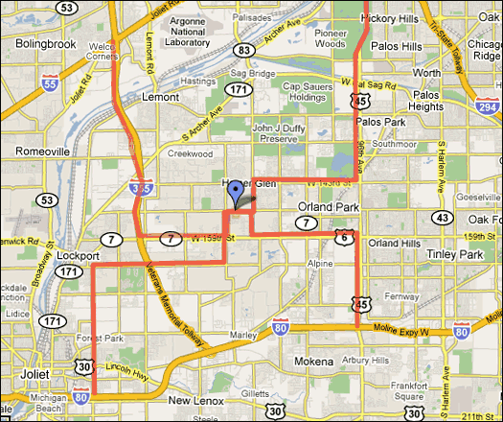

**JOIN US FOR A**

**FUN ON THE FARM**

**BIRTHDAY!**

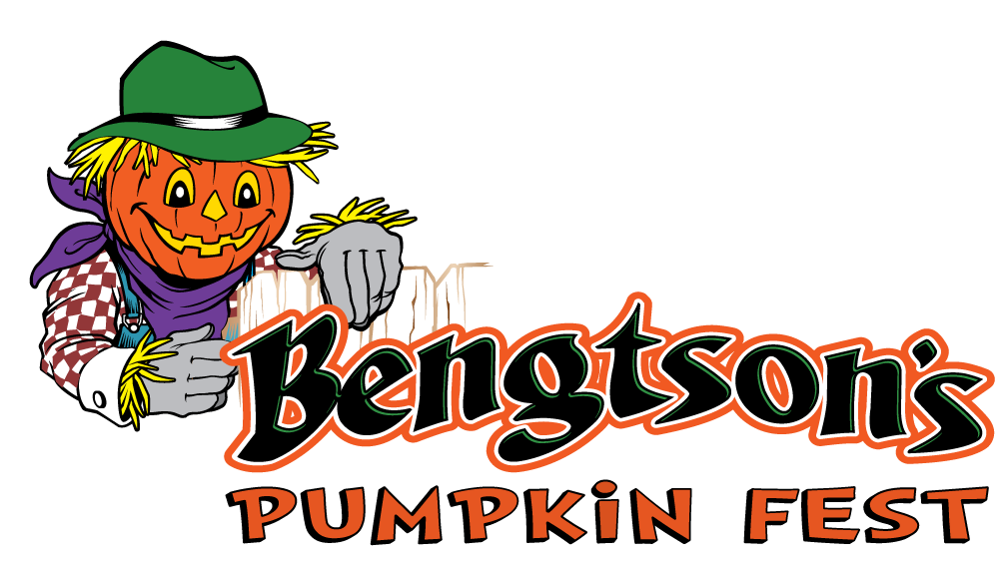

**RIDES, PIG RACES, HAY RIDES,**

**PETTING ZOO & FUN!**

# fOR: ___________________________

**DATE: ___________ TIME: __________**

**WHERE: BENGTSON’S PUMPKIN FEST**

**13341 W 151ST ST.**

**HOMER GLEN, IL 60491**

**R.S.V.P. YAY OR NEIGH**

**TO: _______________________________**